The Little Portion Food Pantry Newsletter
August, 2018

New at the Pantry -
We are now using the Link2Feed system without the assistance of Second Harvest Food Bank personnel. The Catholic Parishes Food Pantry database we had used is using is 10 year old technology and will not be updated.

Congratulations!! Ryan Koonts has attained the rank of Eagle Scout. You may remember his project was installing the benches outside the school cafeteria to give our clients a place to sit while waiting in line to enter the pantry.

Our thanks to -
The folks at the garden for 140 lbs. of fresh cucumbers and 200 lbs. of sweetcorn.
Panera bread for their bread donation (over 322 lbs.).
Allied Churches of Alamance County donation of canned and packaged goods (1561 lbs.).
A generous parishioner for the potato donation (650 lbs.).
Pro Data Research for providing boxes to pack food.
All our volunteers and benefactors for their financial contributions.

Monthly Results – Distribution

Monday 8/6/2018 72 families, 287 individuals over 3200 lbs. of food distributed
Saturday 8/18/2018 99 families, 378 individuals over 5,900 lbs. of food distributed

In addition to canned food and dry goods we distributed the following;
Panera Bread, potatoes, cucumbers (on Monday), sweet corn, bell and jalapeno peppers, onions, meat, eggs, margarine, cheese, head lettuce and carrots.

Stuff A Truck – Weekend (Aug 11/12) donations to this month’s collection totaled 842 lbs. Additional items were donated prior to distribution on Saturday.

Sources of and cost of food for distribution:

Weight Amount
Second Harvest Food Bank 4,614 lbs. $1,437.73
Donated to Pantry 4,409 lbs. $ 0
Local purchase 1,212 lbs. $578.33
Totals 10,234 lbs. $2,016.06

Food Items needed:
Pasta sauce Tuna fish (packed in water),
Canned tomatoes (low or no salt) Spaghetti
Rice Canned fruit (in own juices),
Green beans and corn Oranges
Canned Vegetables (other than green beans and corn) Soap and toilet paper.
Apples Spices and herbs

Gently used kitchenware

Please do not donate expired food. It cannot be distributed.

Next Monday Distribution is on Tuesday September 4th (Monday is Labor Day) from 4:30 to 5:45 at the pantry.
Next Stuff A Truck is weekend of September 15/16
Next Screening (client intake) will be at the pantry on September 22, 2018 beginning at 9:00 am
Next Saturday Distribution is September 22, 2018 (9 am till 12 noon) at the Blessed Sacrament School, 515 Hillcrest Ave. Burlington.

Our thanks to everyone who supports this important ministry. We appreciate your contributions – please designate monetary contributions to “Blessed Sacrament Church – The Little Portion Food Pantry.”

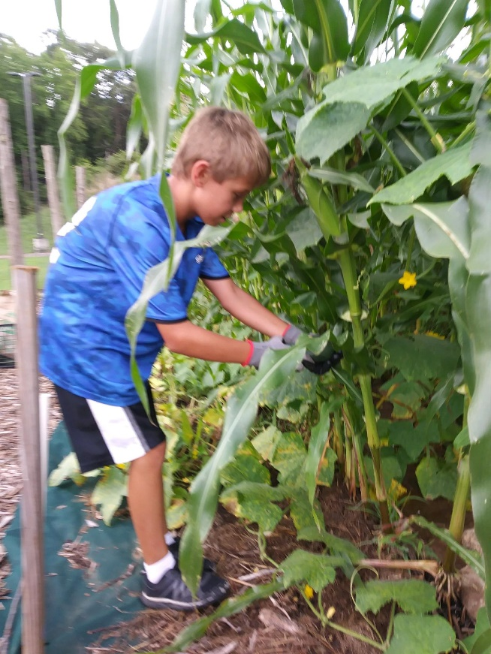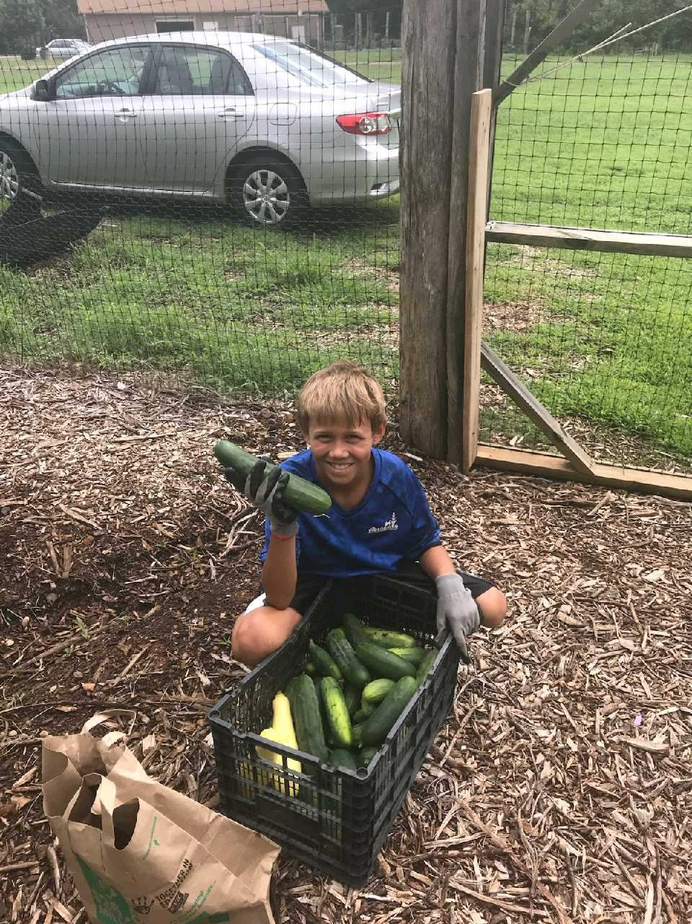

Harvesting cucumbers from the garden for our Monday distribution

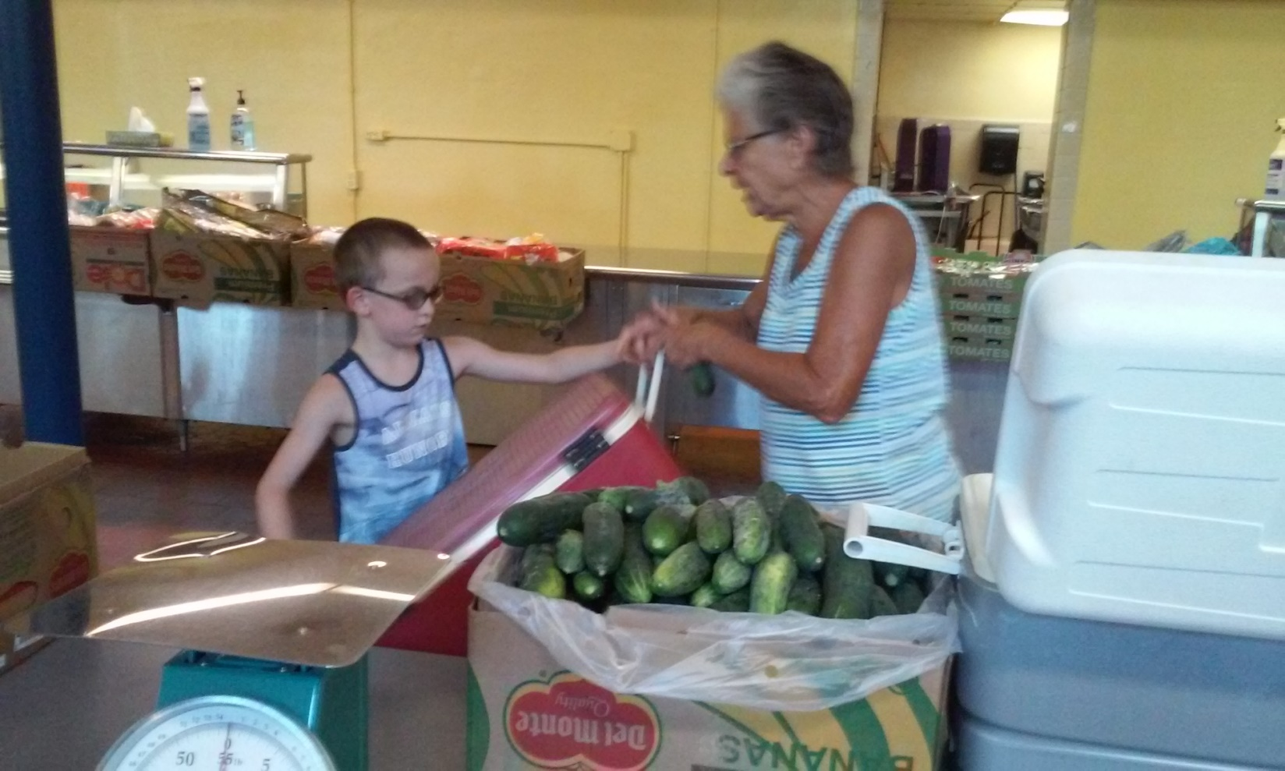

Bagging cucumbers for distribution

Everyone can help at the garden

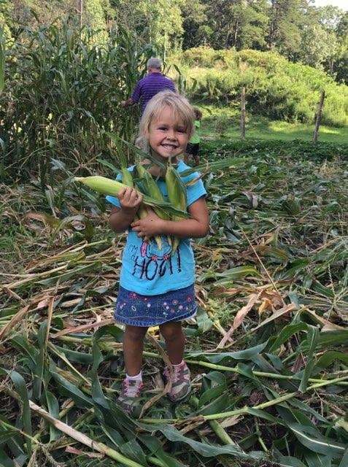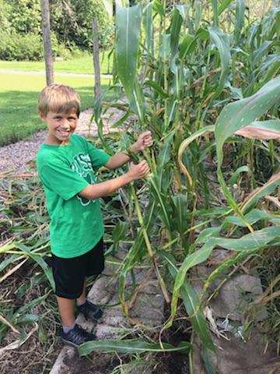

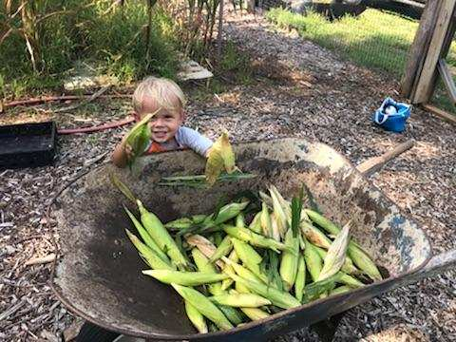

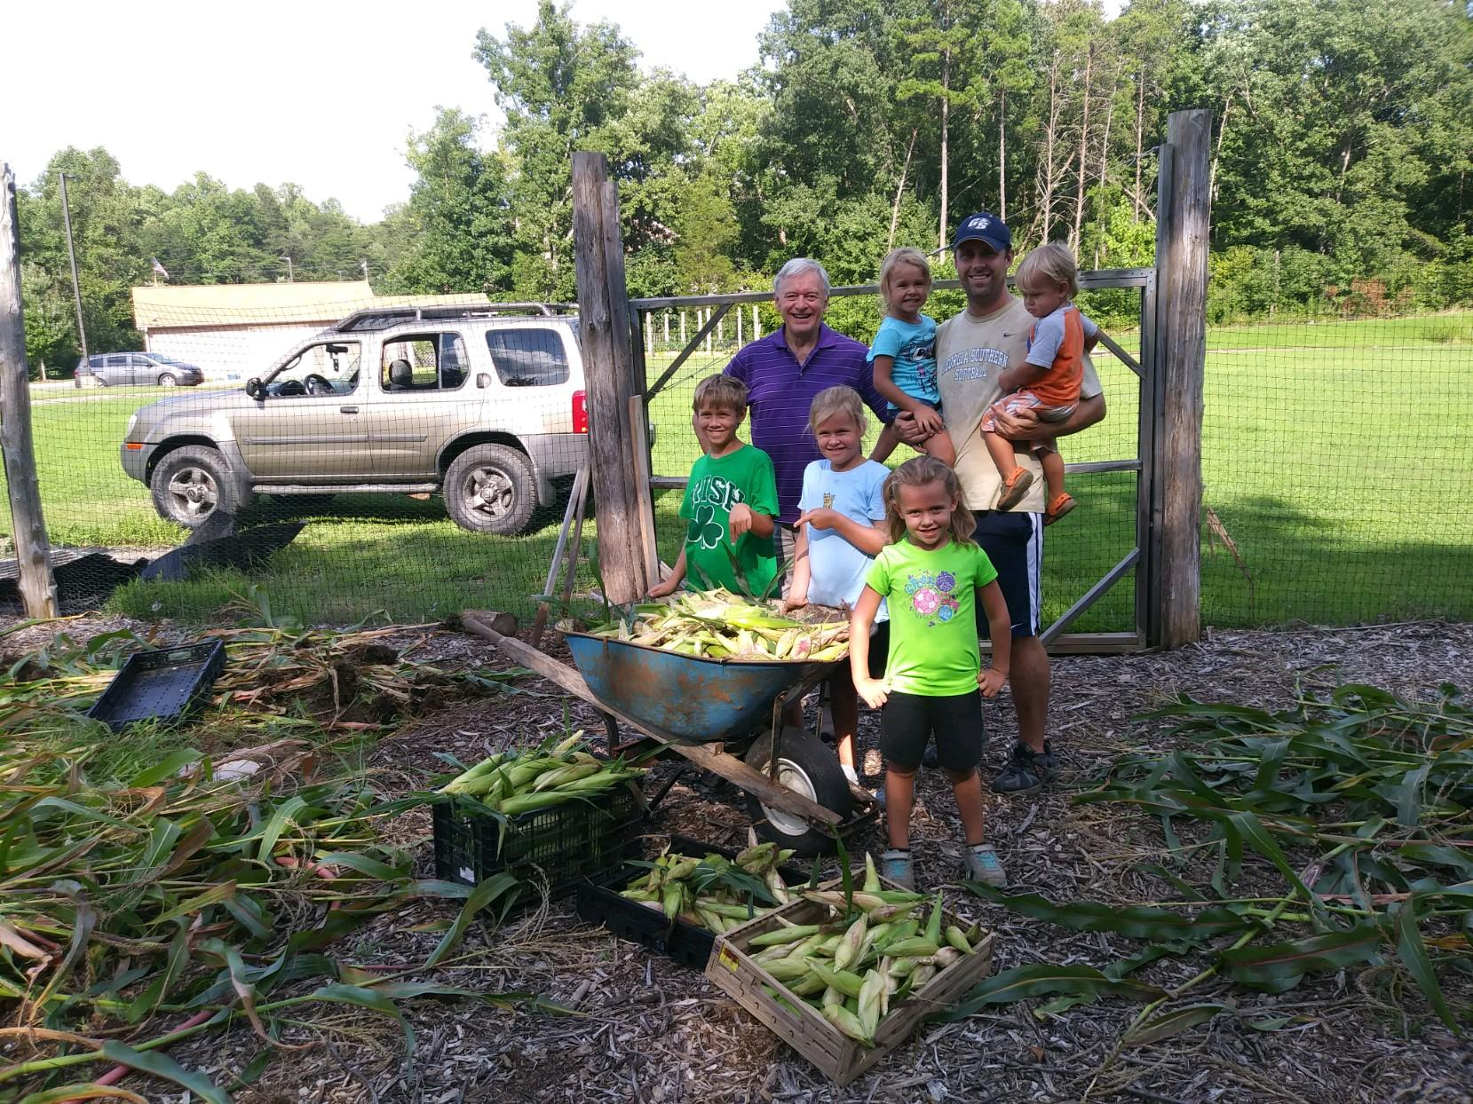

Quality family time

